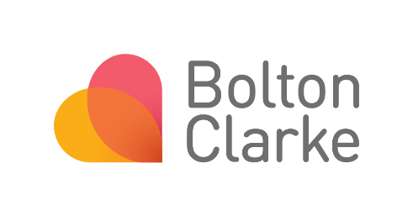
This form must be submitted at the completion of the project to the to the Bolton Clarke HREC (ethics@boltonclarke.com.au). A project is considered complete once data collection is complete, there is no further contact with participants or access to sources of personal health information and the data have been analysed.

Research Project Details
Date of Report: Click or tap here to enter text.
Bolton Clarke HREC Approval Number: Click or tap here to enter text.
Title of Research Project: Click or tap here to enter text.
Primary Investigator: Click or tap here to enter text.
Date of Research Project Commencement: Click or tap here to enter text.
Date Project Approved Until: Click or tap here to enter text.
Have any progress reports been provided?
Choose an item. If yes, date(s) provided: Click or tap here to enter text.
Is this project being withdrawn prior to intended completion?
Choose an item.
If yes, please briefly summarise why:
Click or tap here to enter text.
This report covers the period from : Click or tap here to enter text. to Click or tap here to enter text. and details progress since the last report.

Recruitment
Proposed sample size from Bolton Clarke  Click or tap here to enter text. | Sample achieved to date  Click or tap here to enter text.
Number of clients/residents  Click or tap here to enter text. | Number of clients/residents  Click or tap here to enter text.
Number of staff  Click or tap here to enter text. | Number of staff  Click or tap here to enter text.
Other participants  Click or tap here to enter text. | Other participants  Click or tap here to enter text.

Project Summary and Outcomes
Please provide a summary of the project for the HREC’s information (including aims/objectives, methods and results – no more than 300 words)
Click or tap here to enter text.
Please give a brief summary of your outcomes.
Click or tap here to enter text.
Have the aims of the study been met? If so, describe briefly. If not, please provide reasons why not?
Click or tap here to enter text.
Please provide details of any reports or publications in preparation or arising from the project including thesis progress. If/when final copies are available, please send to ethics@boltonclarke.com.au
Publication
Type of publication  (e.g. report, conference, journal article, media, thesis) | Stage  (e.g. planning, analysis, writing, review, submitted, accepted, early view, published) | Planned finish date | Actual finish date

Click or tap here to enter text.
Is it planned that the participants will be informed of the research project results?
In accordance with the principles of the National Statement on Ethical Conduct in Human Research (NHMRC, 2023)
Choose an item.
If Yes, please provide a copy to ethics@boltonclarke.com.au
If No, please provide an explanation
Click or tap here to enter text.

Primary Investigator Declaration
I confirm that this project was conducted in keeping with the conditions of approval of the reviewing HREC (and subject to any changes subsequently approved).
I confirm that the project was conducted in compliance with the NHMRC National Statement on Ethical Conduct in Human Research (NHMRC, 2023) or as amended.
I confirm that I have not received any information in any form from anyone involved in the project to suggest this report does not accurately reflect the completion or closure of the project.

Signature (insert above)
Name: Click or tap here to enter text.

