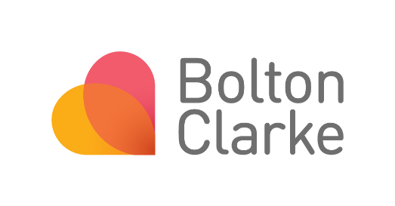

Participant Information Sheet and Consent Form – Person Responsible
Guidance and Template
Instructions for producing a Participant Information Sheet and Consent Form
- This template is appropriate when the potential participant is unable or not competent to provide consent for themselves. It should be targeted at the persons responsible for consenting on their behalf. This Participant Information Sheet/Consent Form should not be used for parents/guardians of children/young people; an alternative template is available for parents/guardians.
- In this template, there are prompts (in purple italics) and instructions (blue italics). Please ensure you that you delete all prompts and instructions from the final document.
- Suggested text for usage is provided under each section.
- Text size should be between 12 to 16.
- The entire document should be reviewed for health literacy. You should aim for a Grade 8 Readability. The following tools will assist you https://www.webfx.com/tools/read-able/ or http://www.readabilityformulas.com/free-readability-formula-tests.php
- Unfamiliar concepts, for example, ‘Consumer Directed Care’, should have a short explanation.
- Unfamiliar medical and clinical jargon should be avoided. If you must use jargon, provide a short explanation.
- Whenever possible, acronyms are not used. If they must be used, they have been spelt out in full with a short explanation.
- The active rather than the passive voice is used, for example, ‘Our nurse will change the catheter’ is better than ‘The catheter will be changed by our nurse’.
- The sections in the template are not exhaustive, and other information may need be included in the informed consent form if the investigator, the funder, and/or the
HREC believes that the information is needed to better inform the participant and assist the decision-making process.
- You may also wish to draw on the NHMRC PICF templates to complement this guidance.

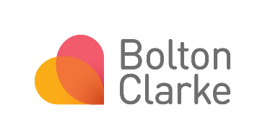
Participant Information Sheet and
Your logo
Consent Form for Participant
to take part: [Person Responsible]

Study date period: | [Dates of Study]
Full study title: | [Study Title]
Short study title: | [Short Study Title]
Researchers: | [Research Team Members and Organisations]

Introduction

The purpose of this section is to state the reason the participant is being invited to take part in the research project and to explain the purpose of the form and the nature of informed consent.

You have been identified as someone who is responsible for someone who is invited to take part as a participant in this research project, which is called [Name of research project]. They have been invited because [Explain reason for invitation].
This Participant Information Sheet/Consent Form tells you about the research project. It explains the processes involved with taking part. Knowing what is involved will help you decide if you want the participant to take part in the research.
Please read this information carefully. Ask questions about anything that you don’t understand or want to know more about. Before deciding whether or not the participant can take part, you might want to talk about it with a relative, friend or your local health worker.
Participation in this research is voluntary. If you don’t wish the participant to take part, they don’t have to.
If you decide you want the participant to take part in the research project, you will be asked to sign the consent section. By signing it you are telling us that you:
- Understand what you have read,
- Consent to the participant taking part in the research project,
- Consent to the participant being involved in the research described, and
- Consent to the use of the participant’s personal and health information as described.

You will be given a copy of this Participant Information and Consent Form to keep.

What is the purpose of the study?
  - The aim of the study and why it is significant
  - How it will fill a knowledge gap or improve care or future research
  - Any relevant background information
  - Whether the study builds on previous research conducted at Bolton Clarke
  - Include a statement that confirms the study has the support of the Bolton Clarke Business Stream Leader (if the project involves Bolton Clarke Staff)
  - Include a statement of who is funding and conducting the research

Who can take part in this study?
  - Outline eligibility criteria for the study
  - You may also include how many people/sites will be taking part in the project, and whether any other groups are involved

The participant can take part in this study if [insert criteria for eligibility].

What does taking part in this study involve?
  - Explain any screening procedures
  - Explain research procedures or activities, including the nature, number and time commitment
  - Any follow up activities
  - Where any research activities will be conducted
  - Any reimbursements of costs
  - Whether any research activities will be recorded (audio/video)

Do they have to take part in this study?
  - Explain that taking part in the study is entirely voluntary.
  - Clearly articulate that choosing not to participate will not impact on any care or relationship with any of the study institutions.
  - A statement should be included that if the participant agrees to take part in the study, they should sign the consent form (if written consent given) and retain information sheet.
  - Include who will collect the consent form, and that a copy can be left with the participant
  - Include a statement of who to contact should the participant decide to withdraw, and the process for withdrawal
  - See example of text below that you can use
No, the participant does not have to take part in this study. It is completely up to you. Most importantly, whether you choose for the participant to be a part of the study or not, their [care or relationship with provider/institution] will not be affected. If you agree to the participant being a part of the study and then change your mind, they will still get the same [care from provider/institution] but any information already collected about them will still be used in our reports, presentations and articles, unless you request otherwise.
If you do decide that the participant can take part in the study you will be given this Participant Information and Consent Form to sign and you will be given a copy to keep.
Your decision whether the participant can or cannot take part, or that they can take part and then be withdrawn, will not affect their routine care, relationship with professional staff or relationship with [Institution].

What happens with the information collected?
  - Provide a description of the level of confidentiality that will be applied to the participant’s private health information and who may have access to the participant’s records, where they are stored and how and when they will be disposed of;
  - Include a statement that data collected may be used to inform publications, reports and conference presentations.
  - See example of text below that you can use
Any information that we collect from the participant will be confidential. If you choose for [potential participant’s name] to be a part of the study, their information will be changed so that no-one can identify them.
All of the participant’s information will be stored securely at [Location]. Only the researchers involved in the study will have access to their information.
We will publish and present the information we collect at conferences and in reports or articles. We will combine [potential participant’s name] information with other people who also participated in the study. However, their name will never be used, and no one will be able to tell that they were part of this study.
In keeping with the Australian guidelines for health related research, we will securely store [potential participant’s name] information for [Length of time dependent on research type and/or organisational requirements] and then it will be destroyed in a secure way.

What are the possible benefits of taking part?
  - Provide a description of possible benefits to the participant or the broader community, if any, that are reasonably expected. Take care not to raise expectations of participant benefits.

By [potential participant’s name] taking part in this study, we cannot guarantee or promise that you or they will receive any benefits from this research. [Outline potential benefits].

What are the possible risks and disadvantages of taking part?
  - Provide a description of possible risks or disadvantages that may be associated with participation in the study, and how participants will be supported. If there are limited risks or disadvantages to participants, but psychological discomfort may be possible, the following wording may be useful.

We do not expect that there are any risks or disadvantages related to [potential participant’s name] participating in this project. However, there is a chance that they may feel worried/some discomfort [Provide reason/situation why they may feel worried/where they may experience discomfort e.g. discussing your circumstances, talking with someone new over the phone/concerned about their health information being collected]. If they do become worried or uncomfortable, the research team [Or appropriate individuals depending on project e.g. Bolton Clarke nurse/care staff member] can refer them to free support services such as Lifeline (13 11 14) or BeyondBlue (1300 224 636; beyondblue.org.au). We can also help by advising you of the process to access psychology or counselling support in your local area, through your General Practitioner who can help set this up.

How do I hear about the study results?

  - Provide information about how the participant will find out about the project results. State how, and approximately when, participants will be provided with a summary of the results e.g., when the research project is completed.
  - All consent forms should provide the option to receive a summary of the results, and request address details of where to send the report (e.g. via email or postal mail)
At the end of the study you will be provided with a one page summary of what the study has found, if you wish. You can indicate this on the consent form.

If you have any questions about this study please contact:
Research Team Member
[Name]
[Role] [Address] [Phone] [Email]

If you have any concerns or complaints about the conduct of this study please contact:
The Secretary
Bolton Clarke Human Research Ethics Committee Level 1, 347 Burwood Highway, Forest Hill, 3131
Phone: 0410 416 251
Email: ethics@boltonclarke.com.au

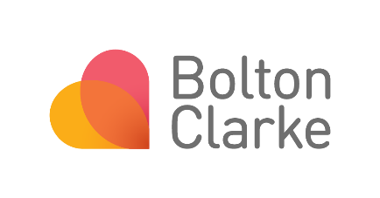
Consent Form: [Person Responsible]
Your logo

Full study title: | [Study Title]

Declaration by Person Responsible
I have read the Participant Information Sheet or someone has read it to me in a language that I understand.
I understand the purposes, procedures and risks of the research project as described.
I have had an opportunity to ask questions and I am satisfied with the answers I have received.
I freely agree to the participant taking part in this research project as described and understand that I am free to withdraw them at any time during the project without affecting their future care.
I understand that I will be given a signed copy of this document to keep.
Name of Participant (in block letters)
...........................................................................................................
Name of Person Responsible (in block letters)
...........................................................................................................

Relationship of Person Responsible to Participant
...........................................................................................................
Signature of Person Responsible :...................................................... Date ………………………..

I wish to receive a one-page summary of the study findings: Yes No

Email /postal address …………………………………………………………………………………………….

Researcher’s declaration:
I have given a verbal explanation of the research study, its procedures and risks and I believe that the participant understood the explanation
…………………………………………………………………………………………………………………………………. (Print name) (Signature) (Job Title) (Date)

